Caitlin Frank – s4091918
RMIT University
Experiment 3 – Electronics

Contents
Exercise 1- Part 1 2
Q1.1: What are the values of 𝑅𝑐, 𝑅𝑒, 𝑅𝑏1 and 𝑅𝑏2 in the circuit you designed? Include the key steps of deciding the values. 2
Q1.2: What are the values of 𝐼𝐵, 𝐼𝐶 and 𝑉𝐶𝐸 in the circuit you designed? Include the key steps of calculation. 2
Q1.3: Is the transistor operated in the active mode? Confirm your answer with calculations. 2
Exercise 1 – Part 2 3
Q2: What is the Multisim circuit schematic you built? Please show a screenshot of the circuit schematic 3
b) Capture the simulation results. 3
Q3: What are the simulated 𝐼𝐵 , 𝐼𝐶 and 𝑉𝐶𝐸 of your circuit? Include the screenshots of simulation results. 4
Exercise 1 - Part 3 4
Q5: Present a table to show the results of 𝐼𝐵, 𝐼𝐶 and 𝑉𝐶𝐸 from: (1) hand calculation (Exercise 1 – Part1); (2) Multisim simulations (Exercise 1 – Part 2) and (3) measurement (Exercise 1 – Part 3) 5
Q6: Compare and discuss the results you filled into the table in Q5. Are the calculation, simulation and measurement result consistent with each other? If they are different, what are the possible reasons? 5
Exercises 2 – Part 1 6
Q1.1: What is the finalised BJT amplifier circuit? Present the finalised circuit diagram in the lab report. 6
Q1.3: What is the input resistance 𝑟𝑖𝑛 and the output resistance 𝑟𝑜𝑢𝑡 of your circuit (𝑟𝑖𝑛 and 𝑟𝑜𝑢𝑡 are shown in Fig. 6). 6
Q2.1: What is the Multisim circuit schematic you built? Please show a screenshot of the circuit schematic. 7
Figure 3: Multisim schematic of the BJT amplifier for AC gain analysis. 7
Q2.2: What is the AC sweep simulation result? Present the AC voltage gain vload/vs v.s. signal frequency plot obtained from Multisim in your lab report. 7
Q2.3: Based on the AC sweep simulation result, what is the mid-band gain of the circuit? 7
Q2.4: What is the simulated input resistance 𝑟𝑖𝑛 (as shown in Figure 6)? Include the screenshots of relevant simulation waveforms and the key steps of analysis/calculations. 8
Q2.5: What is the simulated output resistance 𝑟𝑜𝑢𝑡 (as shown in Figure 6)? Include the screenshots of relevant simulation waveforms and the key steps of analysis/calculations. 8
Exercise 2 – Part 2 10
Q3) Measured Rin: 10
Q4) Measured Rout 11
Q5) Measured Mid-Band Gain 12
Q6) comparison Table 13
Q7: Compare and discuss the results you filled into the table in Q6. Are the calculation, simulation and measurement result consistent with each other? If they are different, what are the possible reasons? 13

Exercise 1- Part 1

Q1.1: What are the values of 𝑅𝑐, 𝑅𝑒, 𝑅𝑏1 and 𝑅𝑏2 in the circuit you designed? Include the key steps of deciding the values.
Rb 1 = 70 k ohms
RC = 2 k ohms
RE = 2k ohms
Rb2 = 90 k ohms
VCC = 90k ohms

Q1.2: What are the values of 𝐼𝐵, 𝐼𝐶 and 𝑉𝐶𝐸 in the circuit you designed? Include the key steps of calculation.
IB = IC/β = 1mA / 335
IB = 2.99μA
IC = 1mA
VCE = Vcc – (Ic * Rc) – (Ie * Re)
VCE = 5V – 2V – 2V = 1V

Q1.3: Is the transistor operated in the active mode? Confirm your answer with calculations.
Yes, as the VBE is equal to 0.7V making it forward biased, with the VCB = Vc – Vb (3V – 2.7V = 0.3V) making the collector greater than the base. Thus, the base emitter is forward biased, with the collector base being reverse biased. This therefore means transistor is in active mode.

Exercise 1 – Part 2

Q2: What is the Multisim circuit schematic you built? Please show a screenshot of the circuit schematic
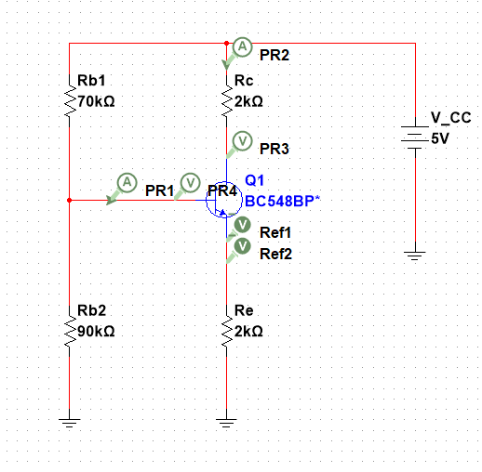

Figure 1: Multisim DC simulation with current and voltage probes to determine IB, IC and VCE

b) Capture the simulation results.

Q3: What are the simulated 𝐼𝐵 , 𝐼𝐶 and 𝑉𝐶𝐸 of your circuit? Include the screenshots of simulation results.
The gain:
$$998.73/4.25 = 235.79$$
IB = 4.25uA
IC = 0.999mA
VCE = 0.997V
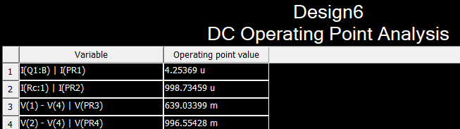

Figure 2: Multisim DC operating point analysis results demonstrating base current, collector current and collector-emitter voltage.

Exercise 1 - Part 3
2.101/2 = 1.505mA
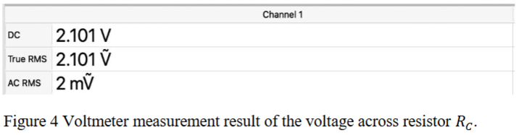
Ib = Irb1 – Irb2
= Vrb1/rb1 – vbr2/rb2
2.37/70k
= 0.33857
=33.857mA
2.64/90 * 100
= 29.3mA
33.857 – 29.3
= 4.53mA
1.0540 * 1000 / 4.53
= 232.21

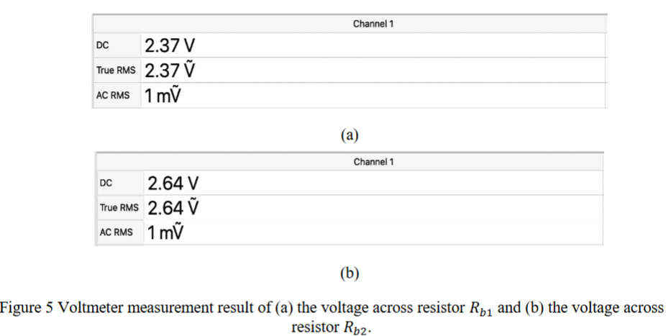

Q5: Present a table to show the results of 𝐼𝐵, 𝐼𝐶 and 𝑉𝐶𝐸 from: (1) hand calculation (Exercise 1 – Part1); (2) Multisim simulations (Exercise 1 – Part 2) and (3) measurement (Exercise 1 – Part 3)
Parameter | Hand Calculations | Simulation | Measurement
IB (μA) | 2.99 | 3.0 | 4.53
IC (mA) | 1.0 | 1.0 | 1.054
VCE (V) | 1.0 | 1.0 | 1.505

Q6: Compare and discuss the results you filled into the table in Q5. Are the calculation, simulation and measurement result consistent with each other? If they are different, what are the possible reasons?
The results demonstrated throughout the report are all reasonably consistent. The slight variations in results can be due to different factors such as component tolerance and measurement accuracy. This could also be potentially due to the simulation using idealised component behaviour as in the real-world resistors and transistors will vary slightly.

Exercises 2 – Part 1

Q1.1: What is the finalised BJT amplifier circuit? Present the finalised circuit diagram in the lab report.
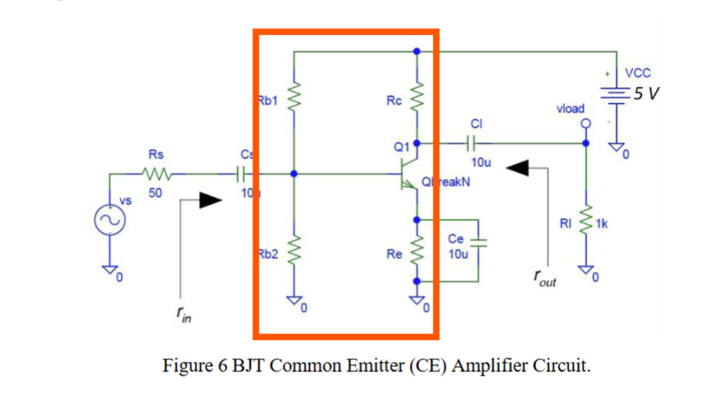
Q1.2: What is the small-signal gain of the amplifier circuit (i.e., 𝑣𝑙𝑜𝑎𝑑/𝑣𝑠)? Assume that the capacitors are acting as open circuits under DC operation and as short circuits under AC operation.
Gain = -Rc/ re
Re = 25mV / IE
re = 25mV * 10^-3 / 1mA * 10^-3
re = 25Ω
Av = -2k / 25 = -80V/V

Q1.3: What is the input resistance 𝑟𝑖𝑛 and the output resistance 𝑟𝑜𝑢𝑡 of your circuit (𝑟𝑖𝑛 and 𝑟𝑜𝑢𝑡 are shown in Fig. 6).
Parallel = ||
Rin = Rb1|| Rb2 || (β * re)
Rin = 70k || 90k|| (335 * 25)
Rin = 5.2kΩ
Rout = RC = 2kΩ

Q2.1: What is the Multisim circuit schematic you built? Please show a screenshot of the circuit schematic.
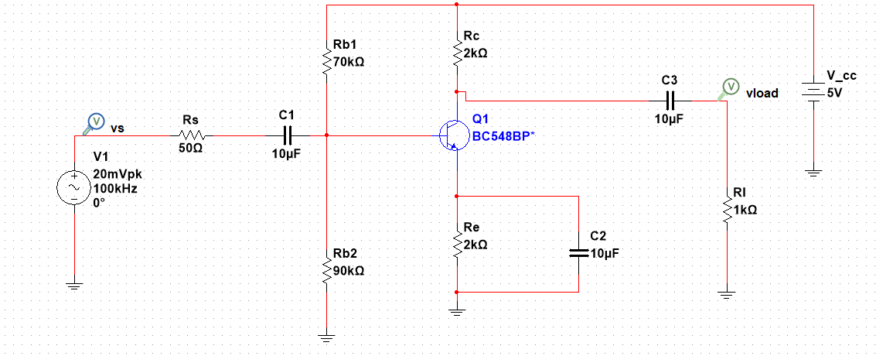

Figure 3: Multisim schematic of the BJT amplifier for AC gain analysis.
Q2.2: What is the AC sweep simulation result? Present the AC voltage gain vload/vs v.s. signal frequency plot obtained from Multisim in your lab report.
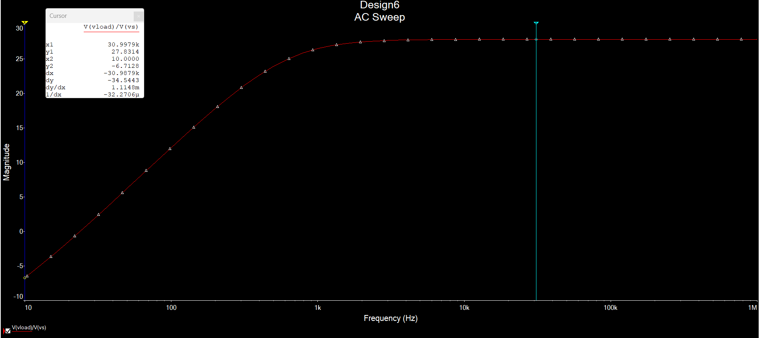
Figure 4: Multisim AC Sweep demonstrating mid-band gain of 27.8dB for BJT amplifier circuit
dB = 27.17dB
Av = 10 ^ 27.17/20 = 22.8 V/V
This thus shows the amplifier maintains a constant voltage gain when in the mid-band frequency range. The graph also demonstrates the gain rising at low frequencies and flattening at around 100kHz.
Q2.3: Based on the AC sweep simulation result, what is the mid-band gain of the circuit?
27.17dB = 10^(27.17/20) = 22.8 V/V
Gain (V/V) = 10^Gain(db)/20 = 10^ 27.17/20 = 22.8V/V
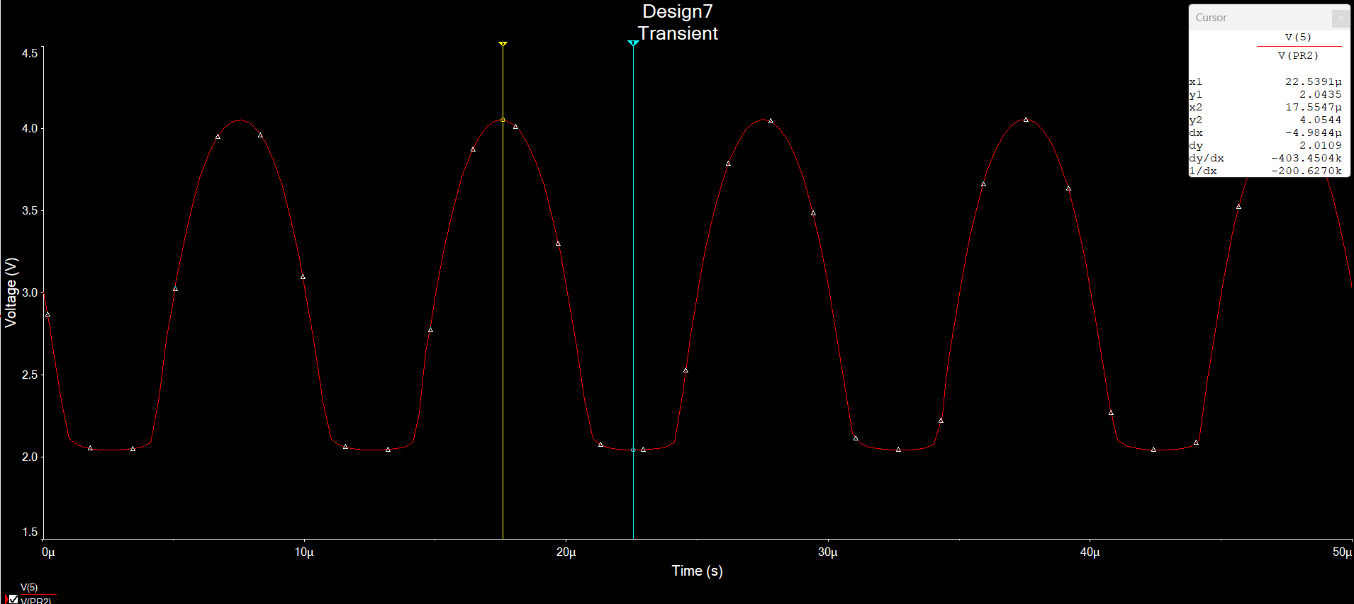

Figure 5: Transient simulation showing amplified output signal

Q2.4: What is the simulated input resistance 𝑟𝑖𝑛 (as shown in Figure 6)? Include the screenshots of relevant simulation waveforms and the key steps of analysis/calculations.
Vin = 347.96 mV
Iin = 6.95uA
Rin = Vin/Iin
Rin = 347.96 * 10^-3/ 6.95 * 10^-6
Rin = 5.22kΩ
How much a signal voltage drops is due to the input resistance thus its important to avoid loading the signal.

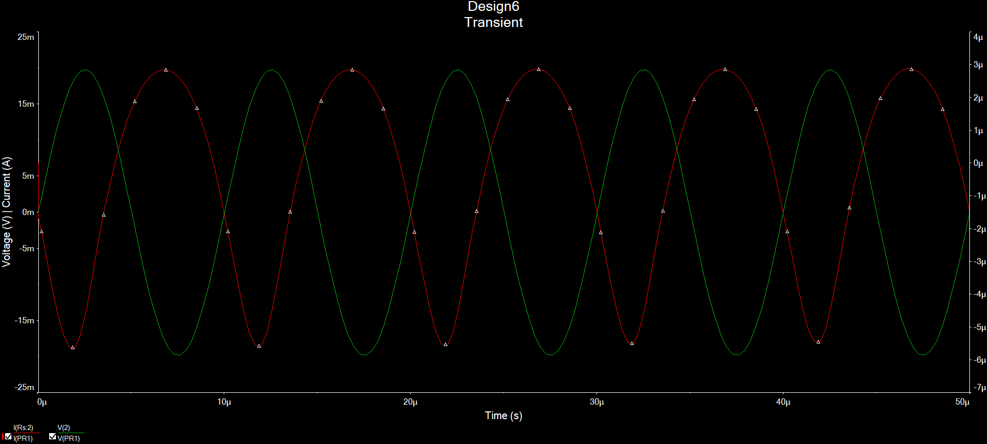
Figure 6: Transient simulation of input voltage (red) and current (green)
Q2.5: What is the simulated output resistance 𝑟𝑜𝑢𝑡 (as shown in Figure 6)? Include the screenshots of relevant simulation waveforms and the key steps of analysis/calculations.
Rout = RL ((vo(open)/Vo) – 1)
Rout = 1kΩ * ((2.0065/0.9382) – 1)
Rout = 1kΩ * (2.138 – 1)
Rout = 1kΩ * 1.138
Rout = 1.14kΩ
The input resistance will affect how well the amplifier can drive a loud with a lower rout being the goal. This is the desired result due to it minimizing signal loss across the load.

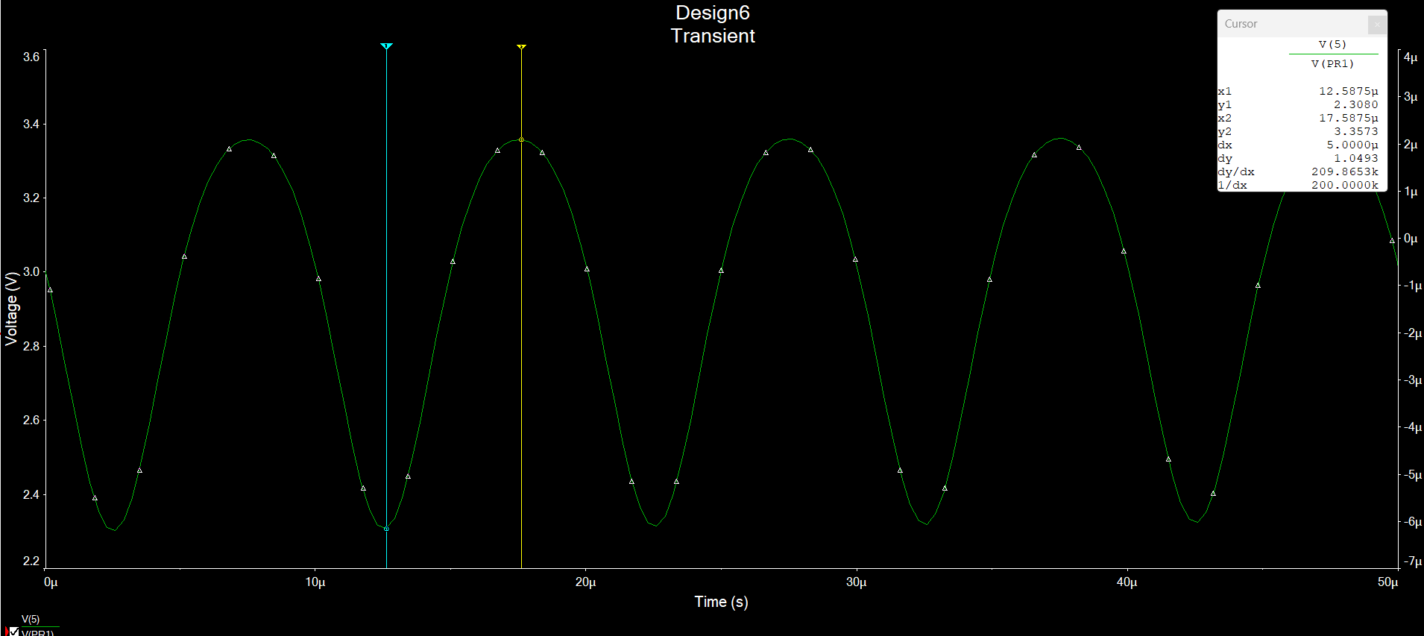

Figure 7: Transient output voltage waveform with no load connected.
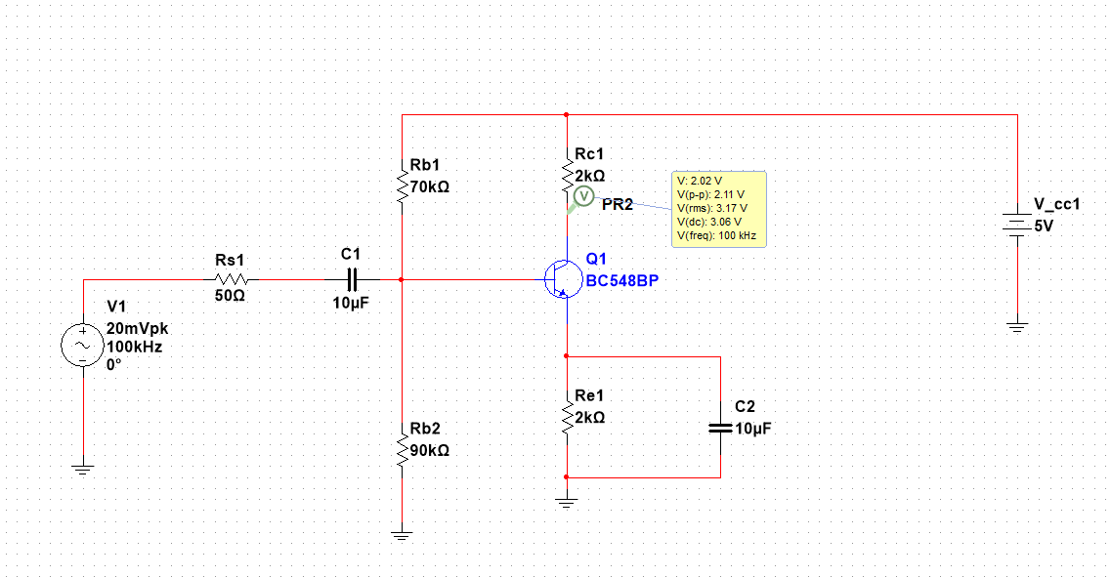
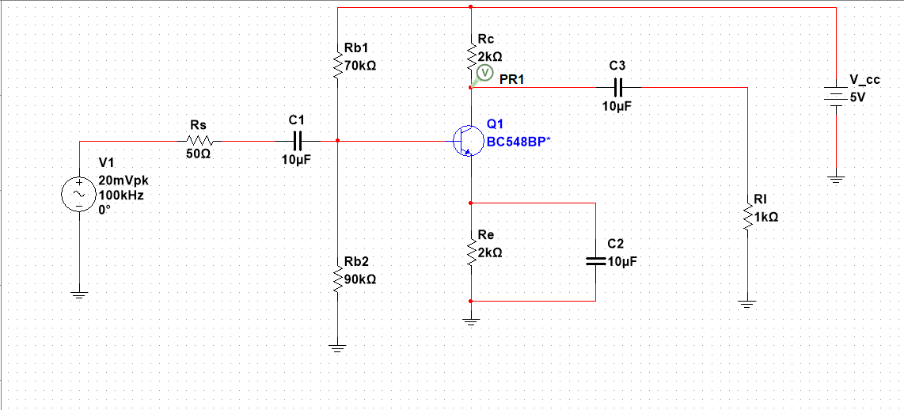

Exercise 2 – Part 2

Q3) Measured Rin:
Iin = VRs/ Rs = 347.9619/50 = 6.95μA
Vin = 43.5788mV Rin = 43.5788 / 6.95μA = 6.27kΩ
The rin for the measured values was higher than what’s seen in the simulated values because of the probe effect or potentially due to resistance not purposely added but existed previously. This can happen because the components are perfect and therefore can introduce extra resistance inside them.
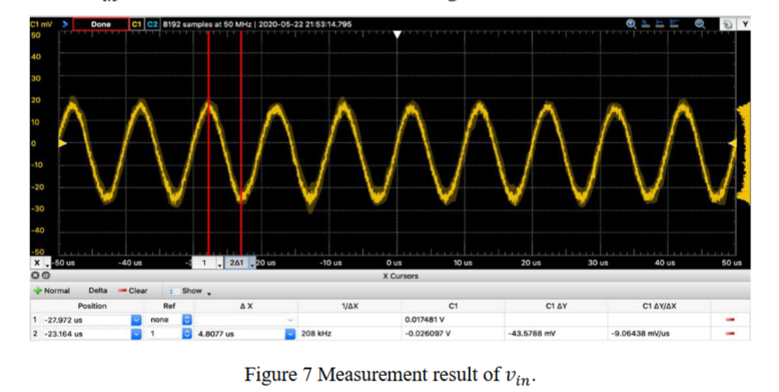
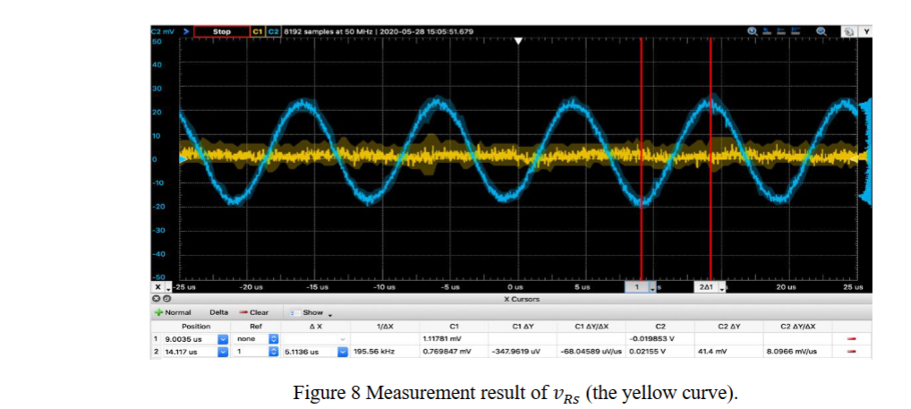

Q4) Measured Rout
Rout = 1k((2.0065 / 0.9382) – 1)
1.13876 * 1000 Rout = 1.14kΩ
Rout = 1.14kΩ
Measured rout values are similar to the simulated values therefore validating the figure.
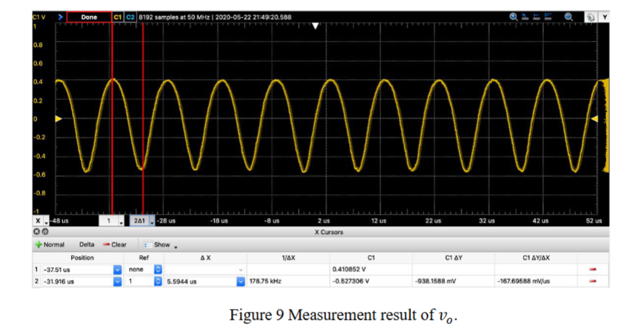
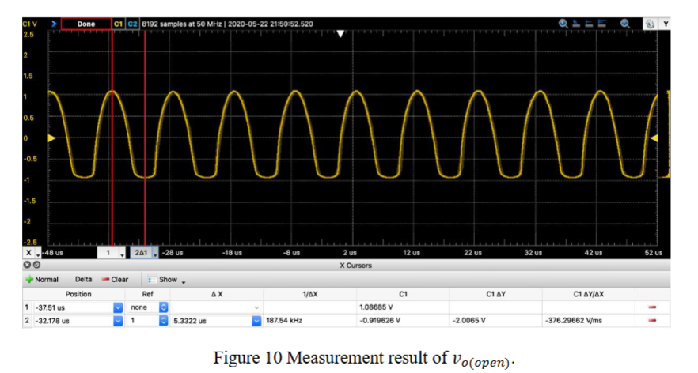

Q5) Measured Mid-Band Gain
Gain(dB) = 27.17 dB
Av = 10^ Gain(dB)/20)
Av = 10^ 27.17/20
Av = 10^1.3585
Av = 22.8 V/V
27.17dB = 22.8 V/V
Cursor 1 is used due to being in the flat surface. Cursor 2 is showing the cutoff value
therefore: 27.17dB
This shows how much the signal is amplified without having to deal with distortions or attenuation as well as validating the figure to make sure that the theoretical, simulated and measured results are correct.
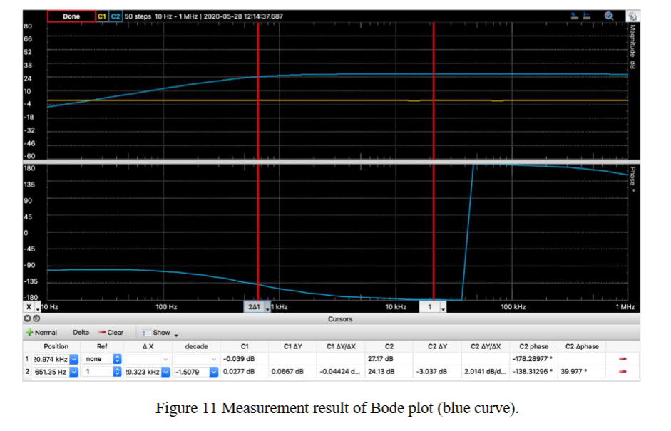

Q6) comparison Table
Parameter | Hand Calculations | Simulation | Measurement
Mid-band Gain | 80V/V | 22.8 V/V | 22.8V/V
Rin (Ω) | 5.2k | 5.22k | 6.27k
Rout (Ω) | 2k | 1.14k | 1.14k

Q7: Compare and discuss the results you filled into the table in Q6. Are the calculation, simulation and measurement result consistent with each other? If they are different, what are the possible reasons?
All the results seen in table above are within a similar range with the simulated and measured results being closer than the hand calculations. This could be due to ideal environment being assumed. The gain difference can be explained through the re approximation and the capacitor effects. Rout and Rin are also slightly different due to the slightly differences in the model parameters as well as real world factors. Thus in conclusion all the values are within the expected tolerance therefore confirming that the amplifier was designed and implemented the right way.

